Chapter 4
How to use the application
Login form:
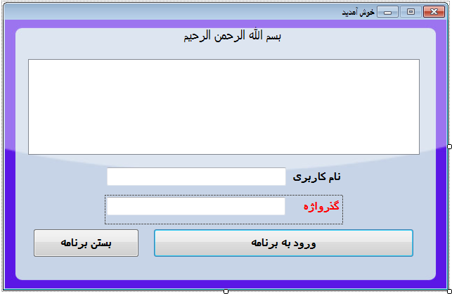
This for is consists of a TreeView, two Textboxes, a Button and two Labels. The TreeView is for showing registered users.
Two Textboxes are used for reading entered user-name and password. The login form is for confirmation of username and passwords whereas the close button is for canceling the logging in process.
The most important function which included in this form is loadUsers().
This function is for loading all available users and show them as a tree view information. This function takes no parameters and returns no data.
private void loadUsers()
{
try
{
listView_users.Clear();
for (int i = 0; i < lbx_users.Items.Count; i++)
{
if (pSDatabase5DataSet.usersTable.Rows[i]["user_limitType"].ToString() != "0")
{
listView_users.Items.Add(pSDatabase5DataSet.usersTable.Rows[i]["user_name"].ToString(), (int)pSDatabase5DataSet.usersTable.Rows[i]["user_PicIndex"]);

if (pSDatabase5DataSet.usersTable.Rows[i]["user_PicPath"] != DBNull.Value)
{
string sPicPath = pSDatabase5DataSet.usersTable.Rows[i]["user_PicPath"].ToString();

try
{
imageList1.Images.Add(Image.FromFile(sPicPath));
}
catch
{
}
listView_users.Items[i-1].ImageIndex = imageList1.Images.Count - 1;
}
else
{

}
}
}
}
catch (Exception ex)
{
MessageBox.Show(ex.Message);
}
}

This loadUsers() method is been called in Form_Load and displays all users in the treeView Control as well as their profile avatar.

